CREATE IBM WATSON IOT PLATFORM AND DEVICE CREATE IBM WATSON IOT PLATFORM AND DEVICE

|  |  |
| --- | --- |
| Date | 25 October 2022 |
| Team ID | PNT2022TMID40560 |
| Project Name | Gas leakage monitoring and alerting system for industries |

# AIM:

To create the IBM Watson IoT platform and device.

**Steps to be followed**

Step 1: Firstly, create an IBM cloud account with IBM id and password.

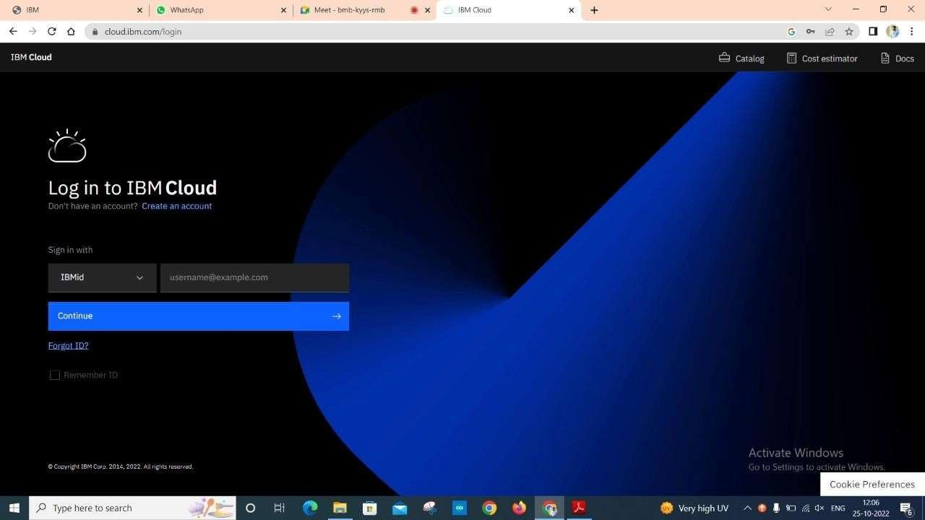

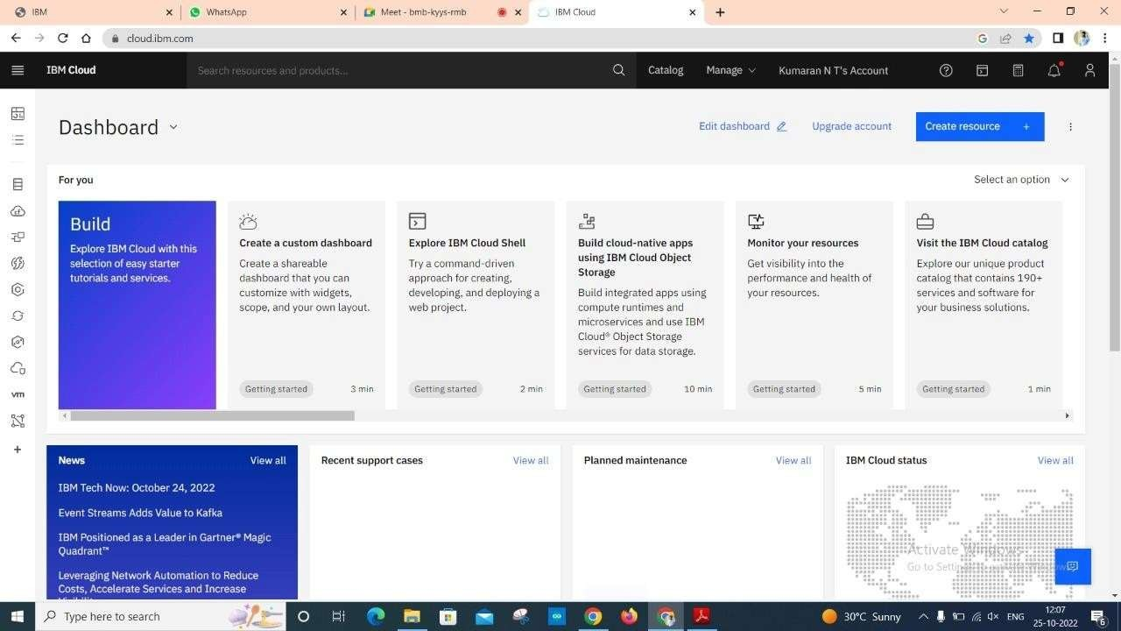

Step 3: Click on the catalog on the top.

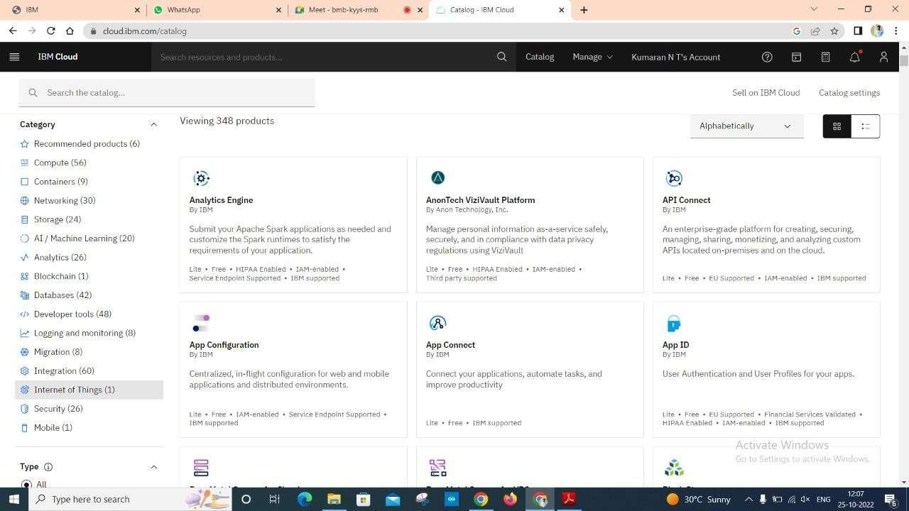



Step 5: Click on Internet of Things Platform.

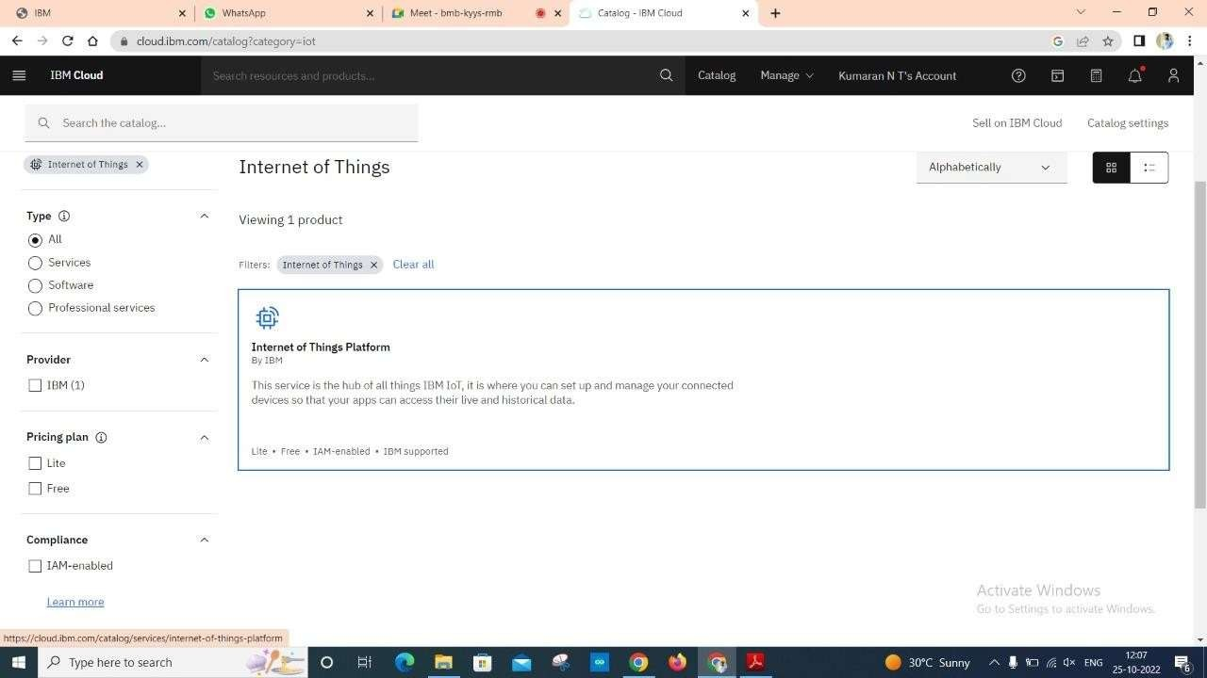

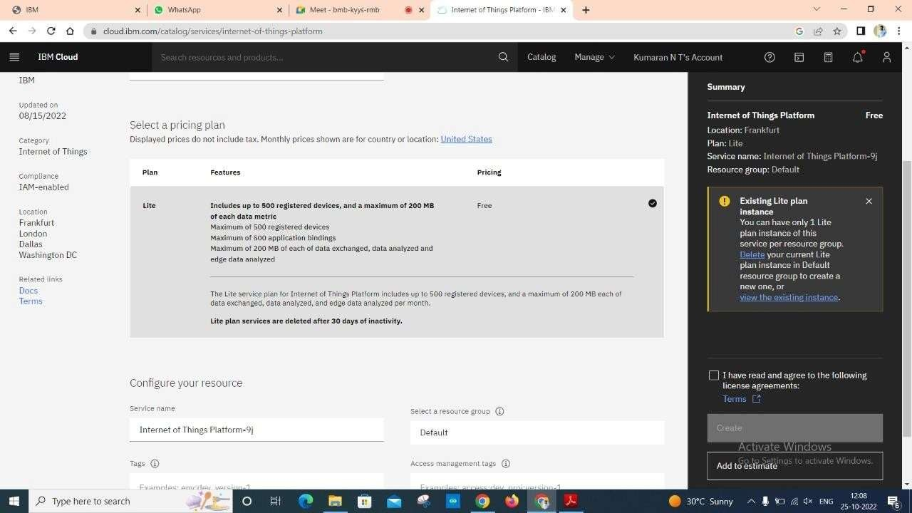

Step 7: Tick agreements and then click on create.



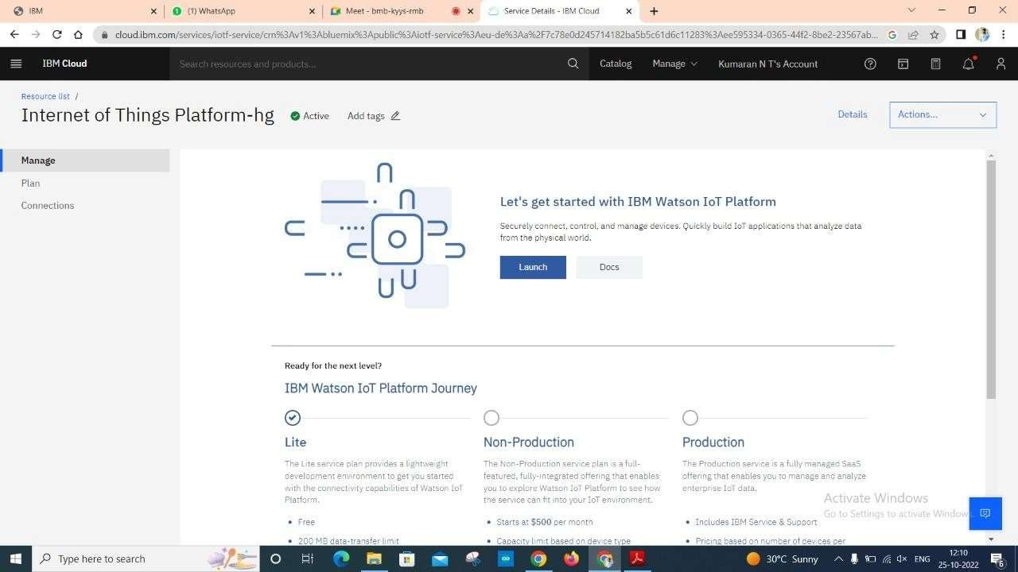

Step 9: After clicking on the launch button this tab will open.

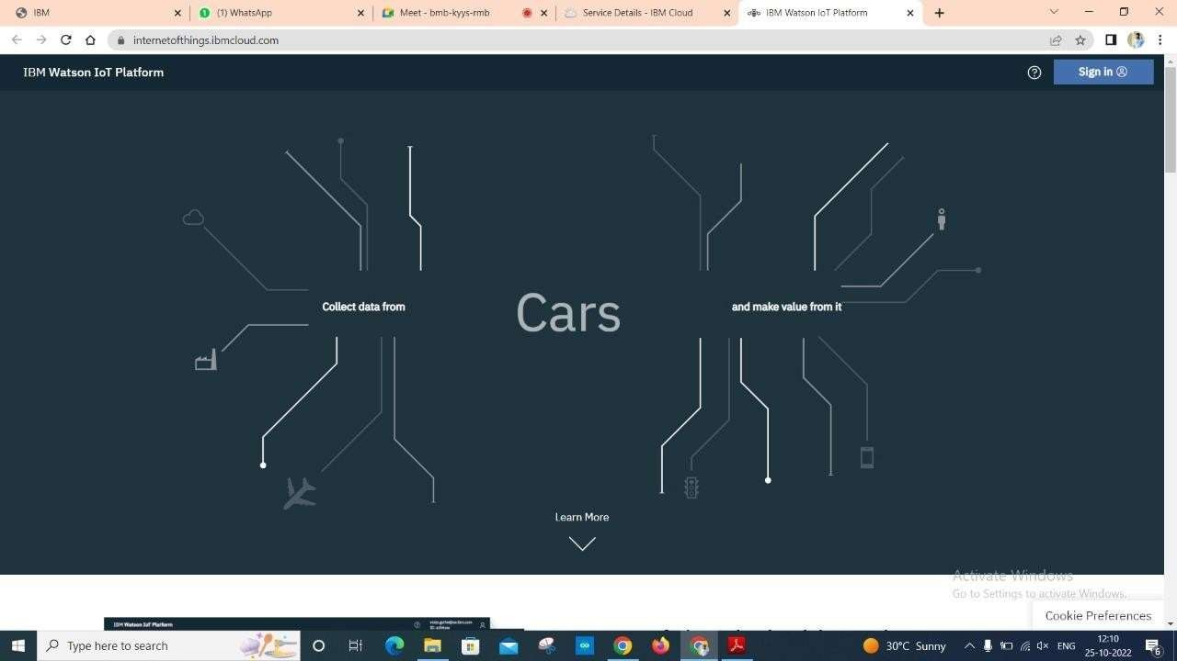



Step 11: Fill the login details.

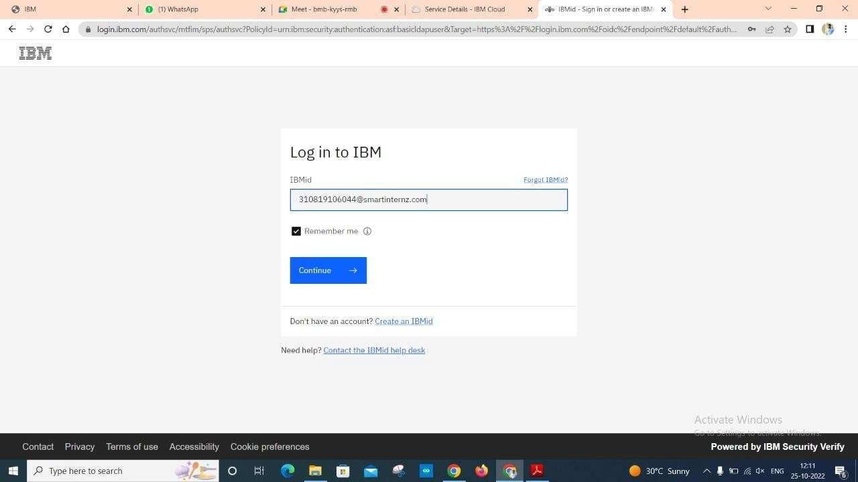

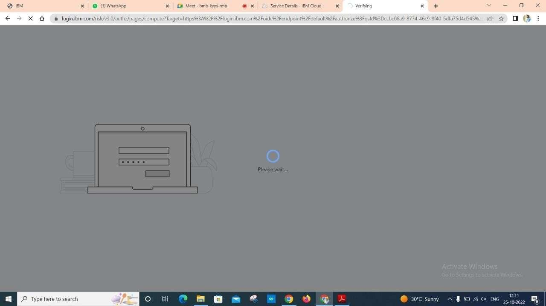

Step 13: Once it id logged in, the name will be displayed click on it and then click on Bluemix Free.

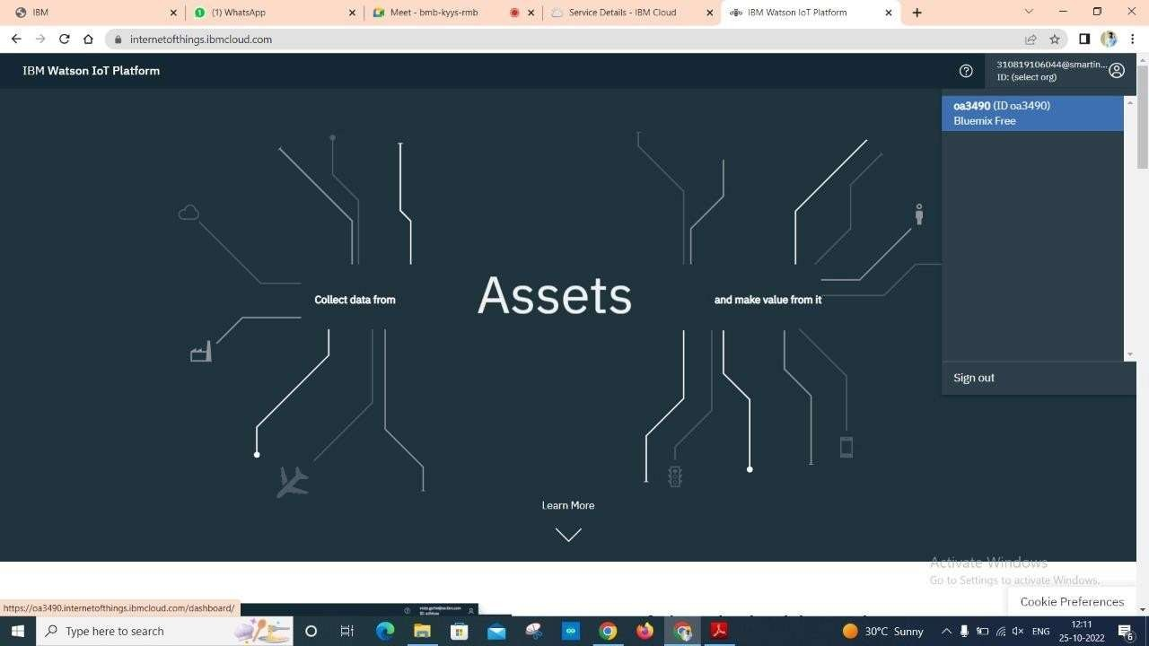

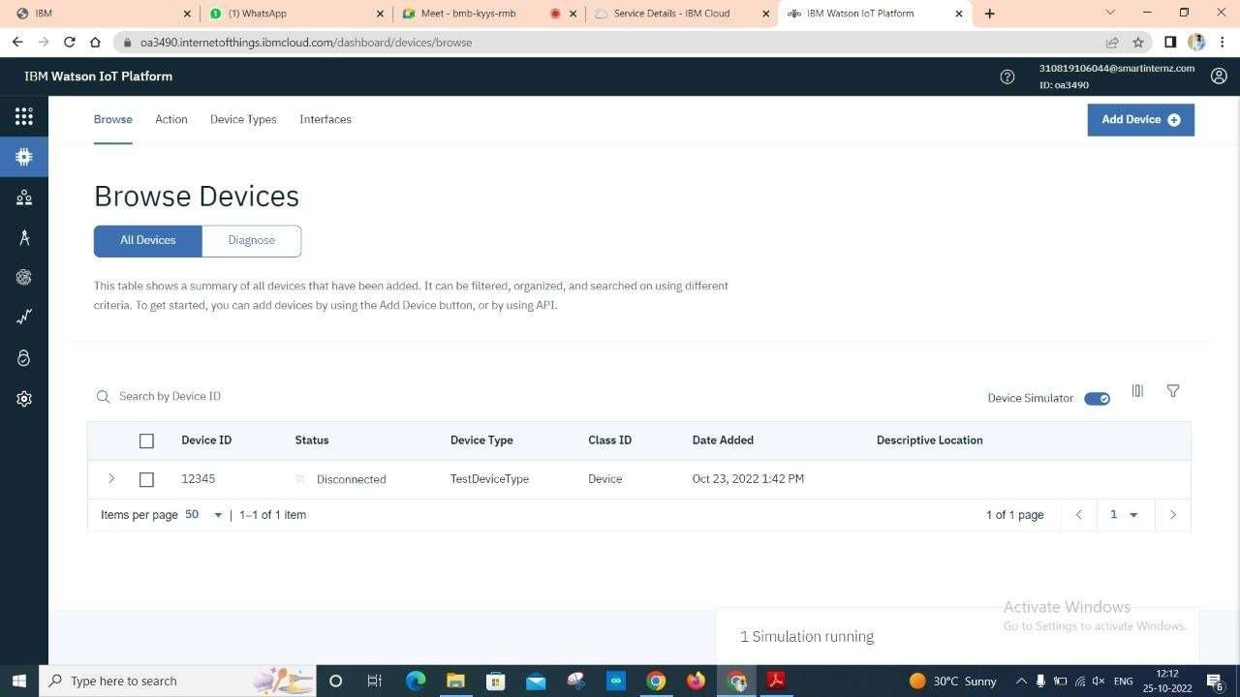

Step 15: Click on Add Device.



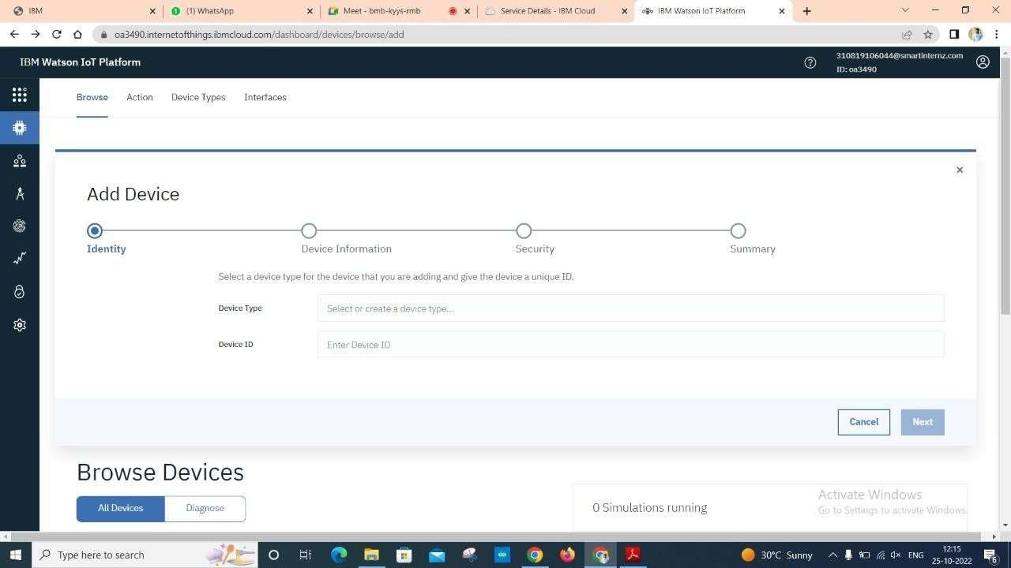

Step 17: Fill the details.

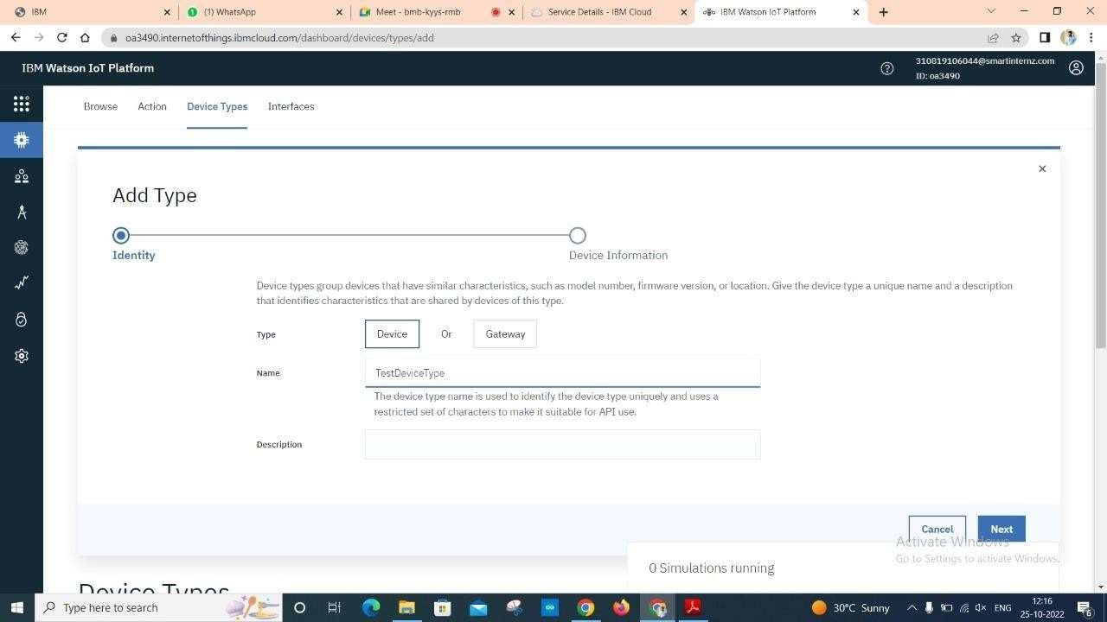

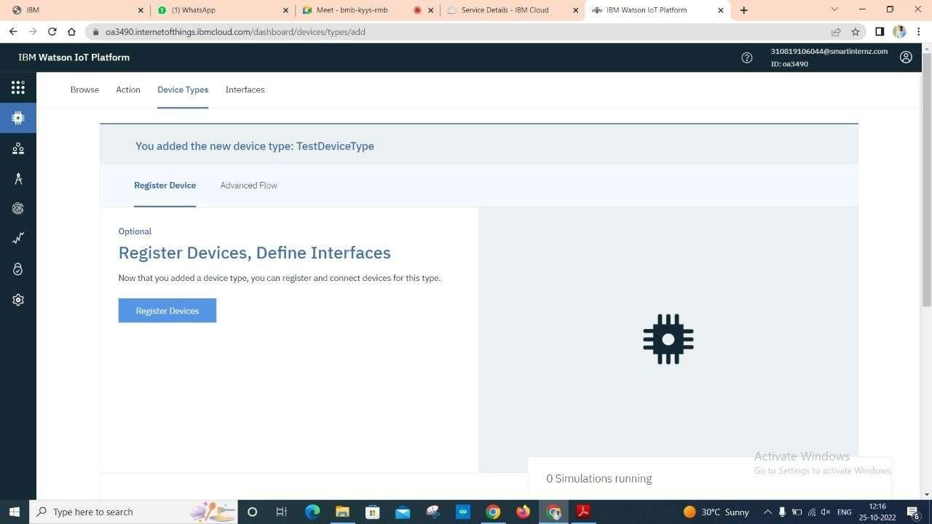

Step 19: Give the device name which you have created and give Device ID.

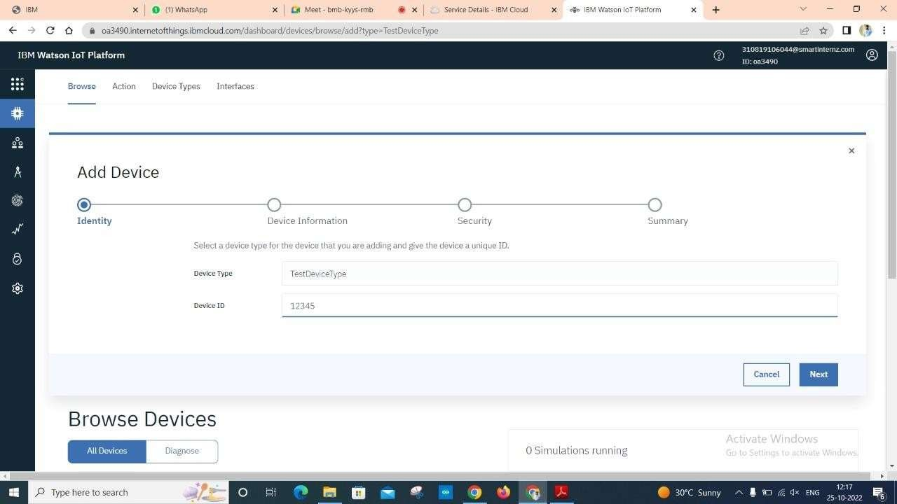

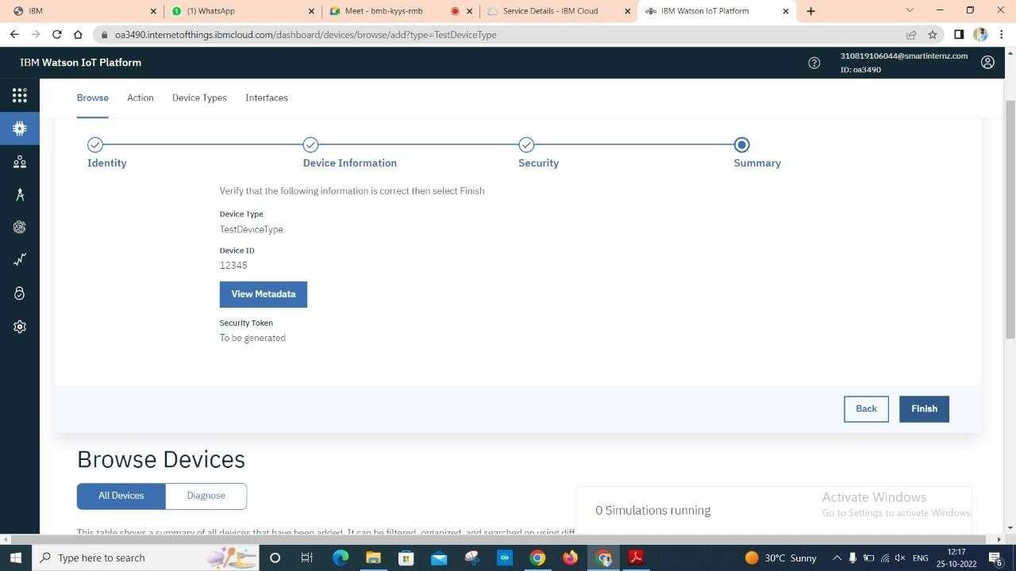

Step 21: After creating the device, Copy the Device Credentials.

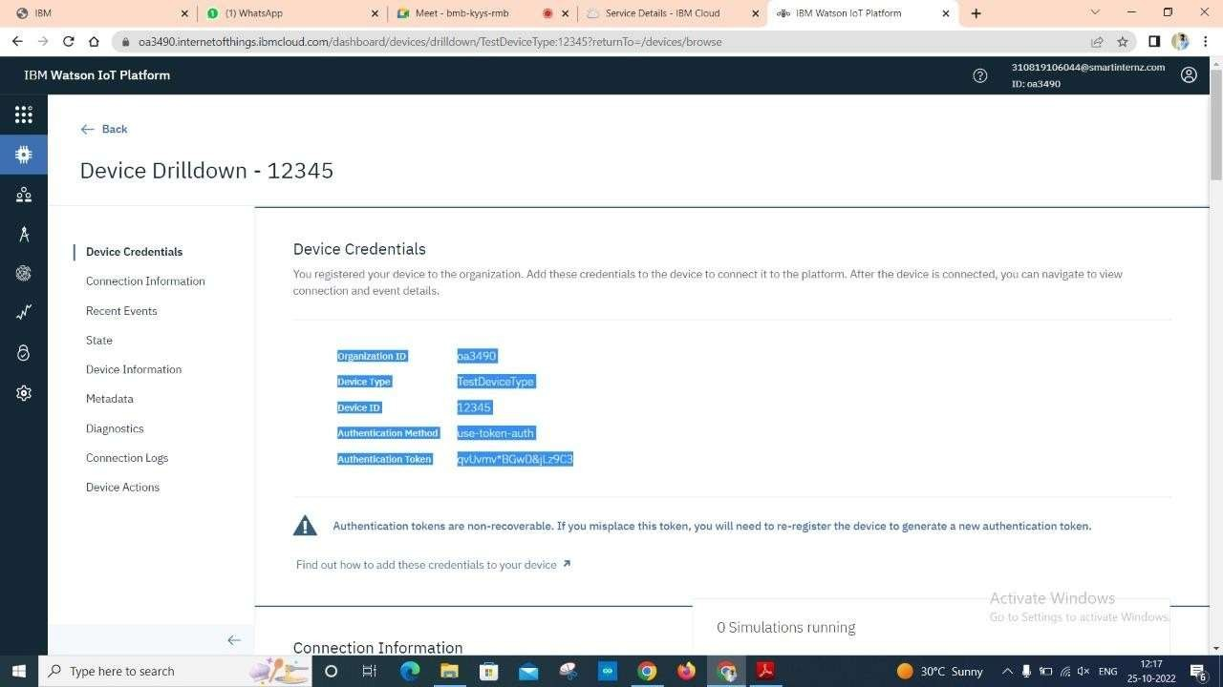

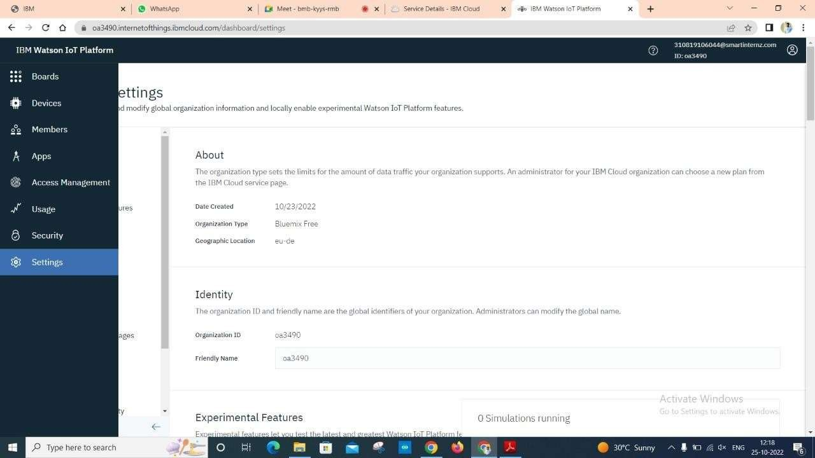

Step 23: Then click on Device Simulator and Activate Device Simulator.

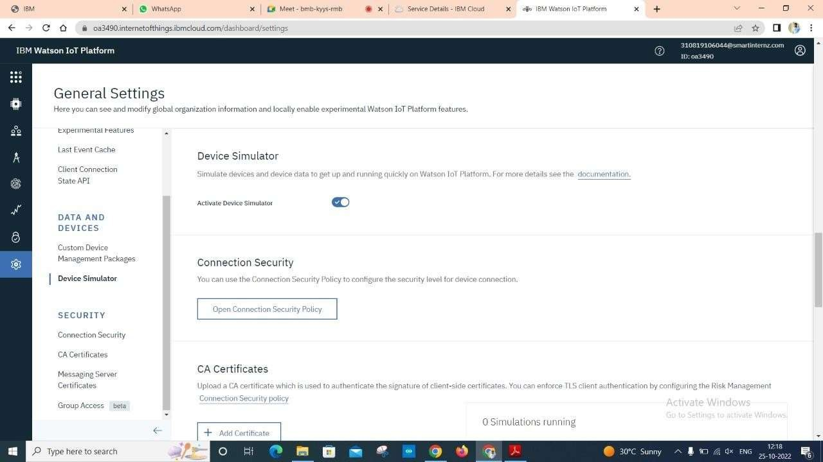

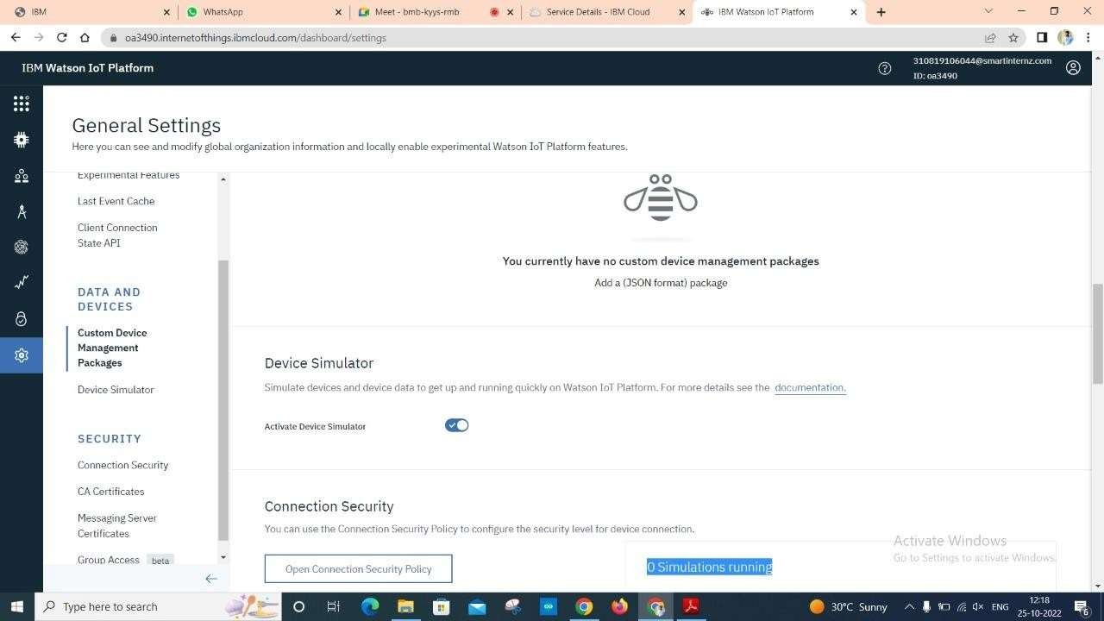

Step 25: Click on Create Simulation.

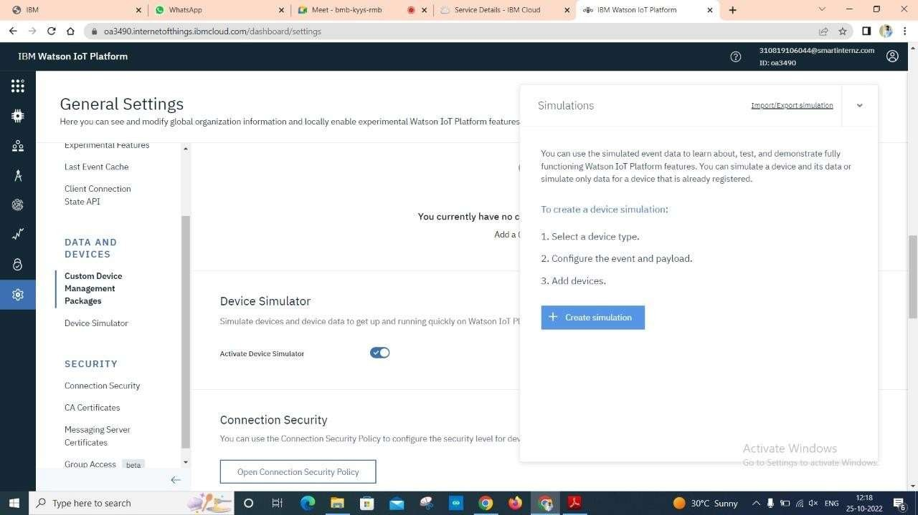

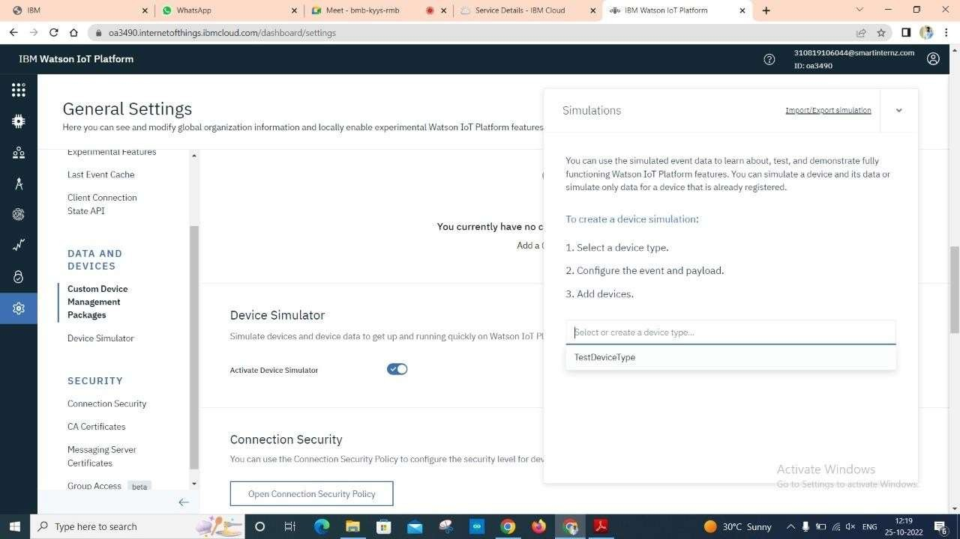

Step 27: Type the code.

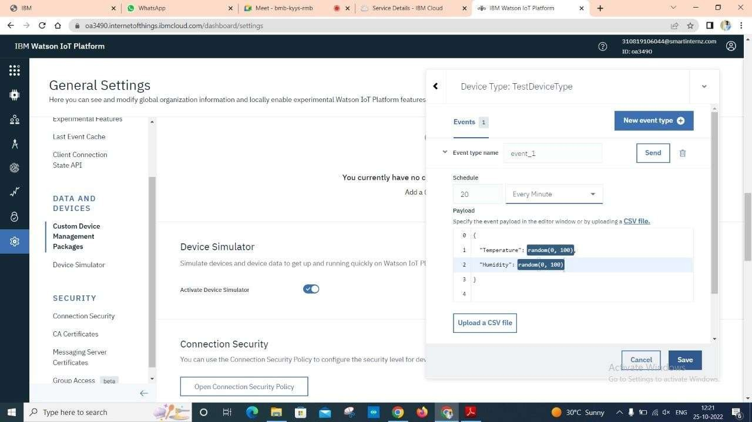

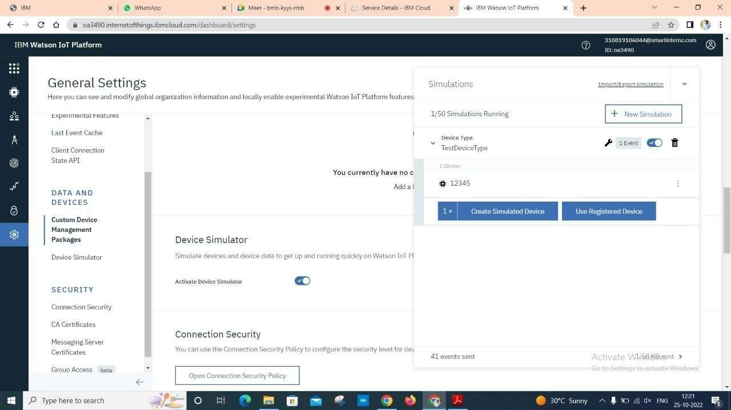

Step 29: Go to devices then click on devices and check the recent events whether the code is running or not.

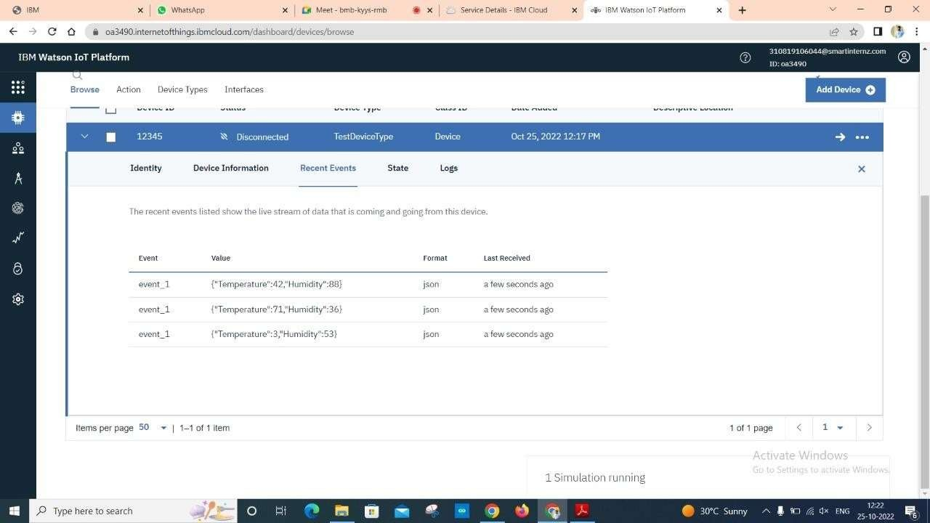

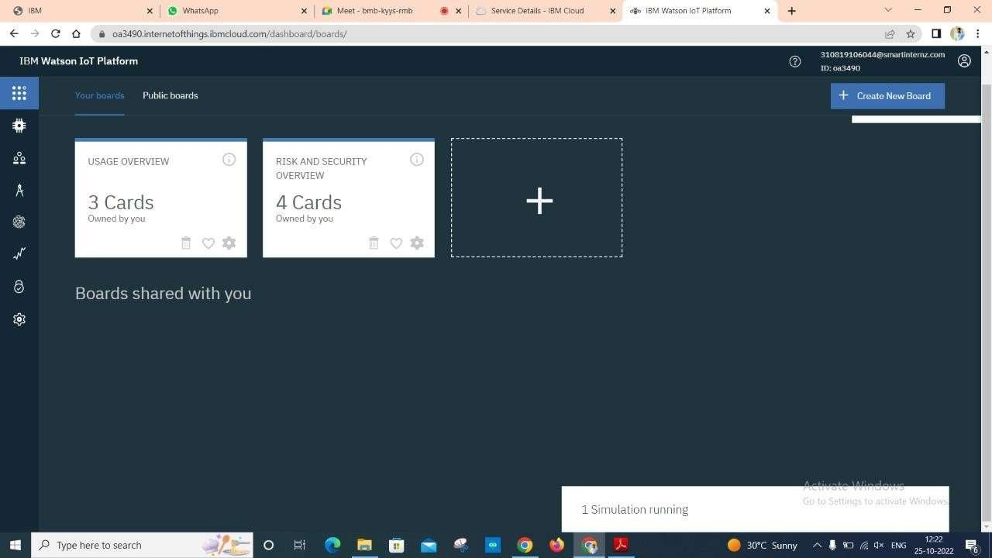

Step 31: Click on the board which is created.

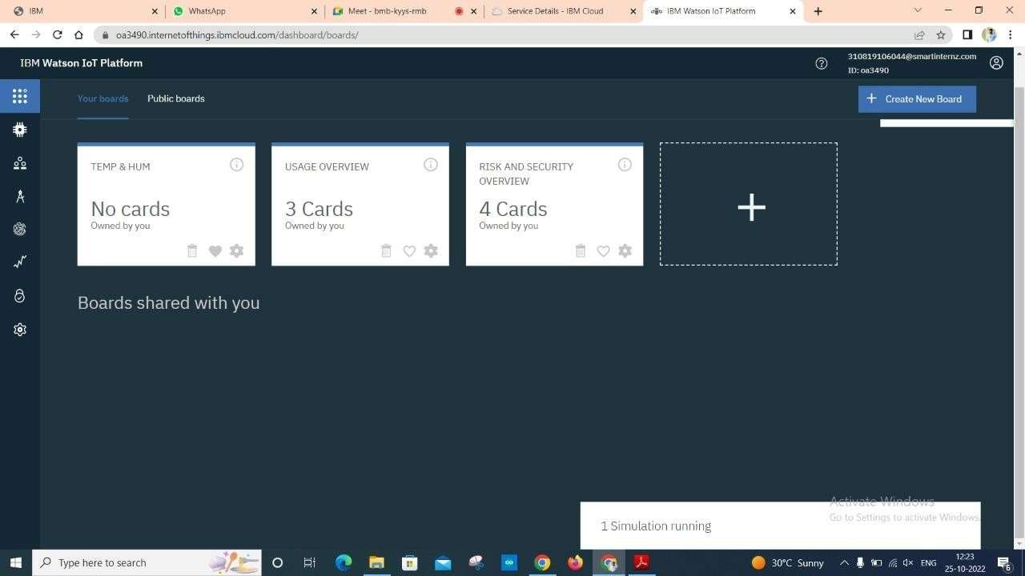

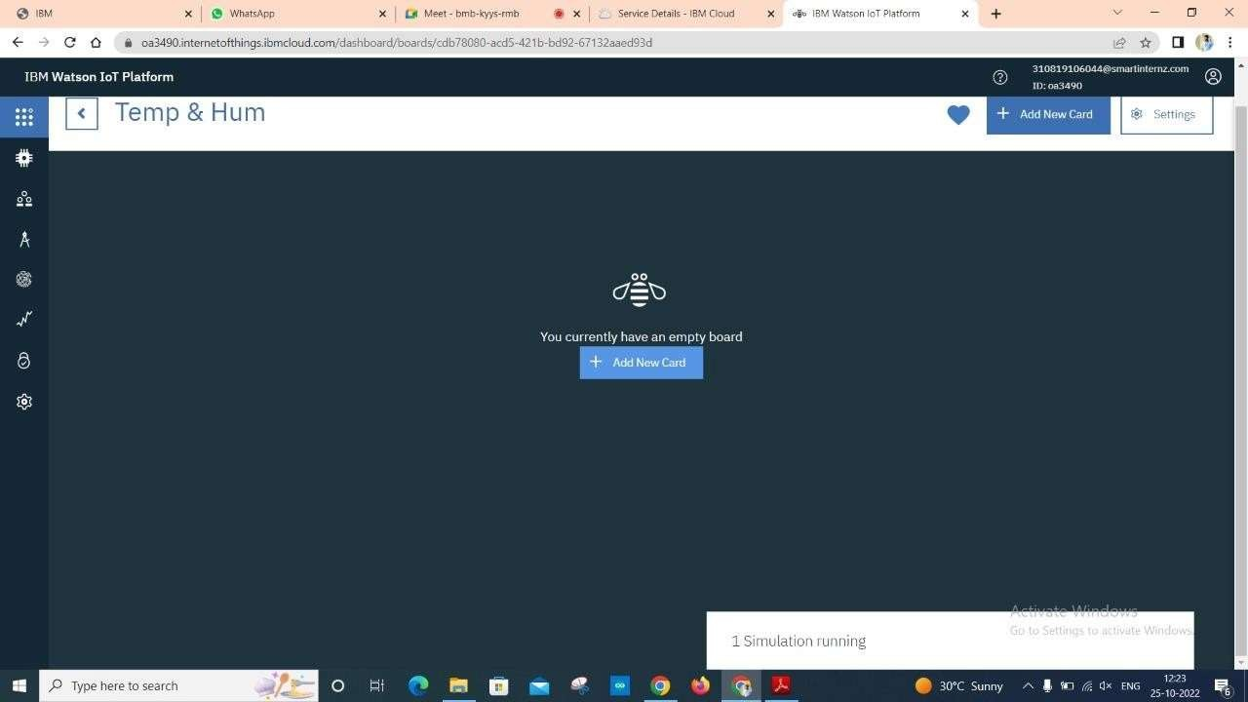

Step 33: Choose the Card Type.

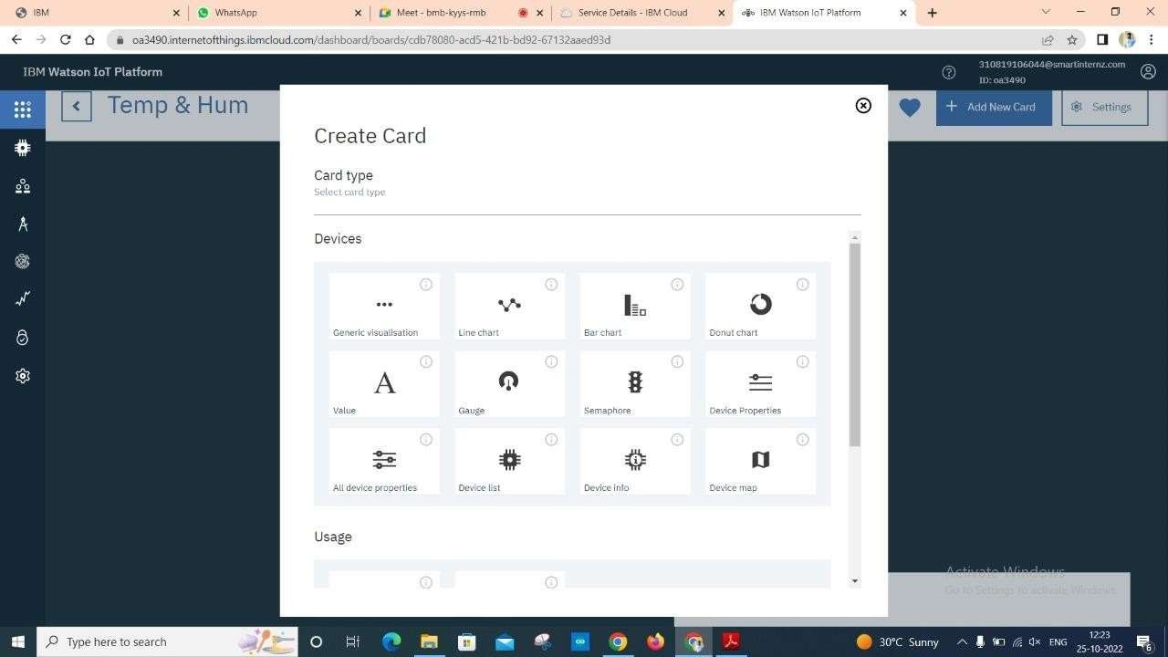

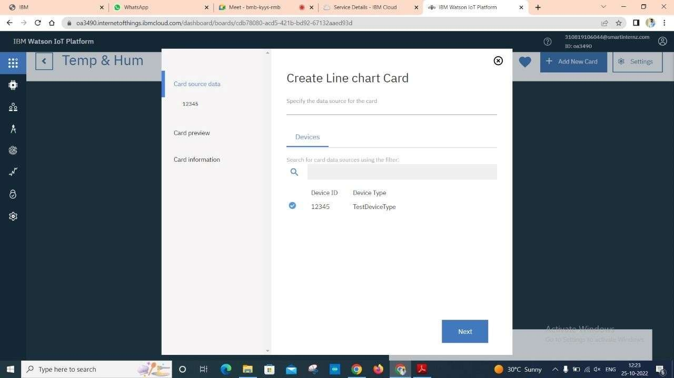

Step 35: Click on Connect new data set.

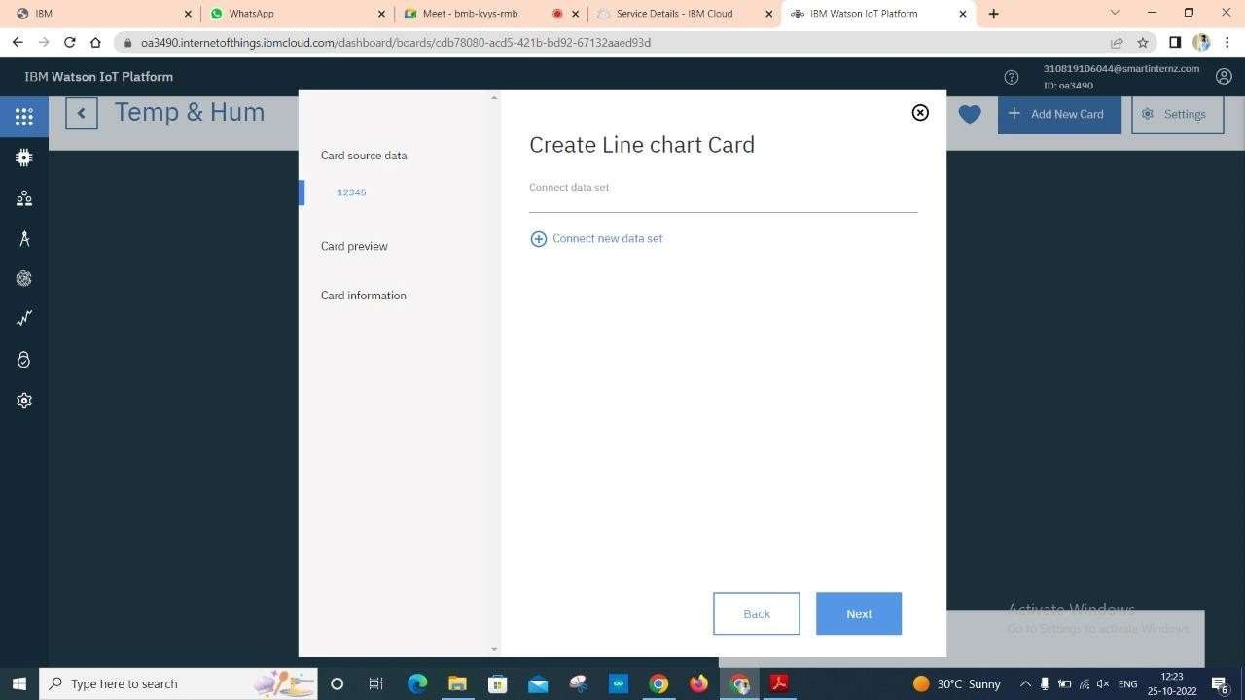

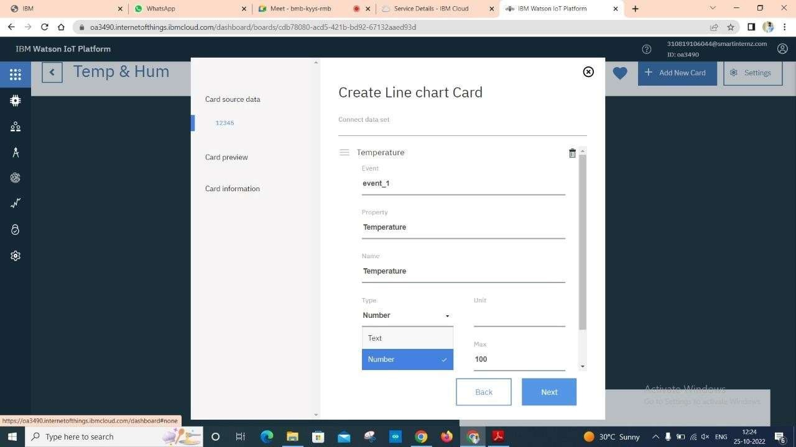

Step 37: Choose the Colour.

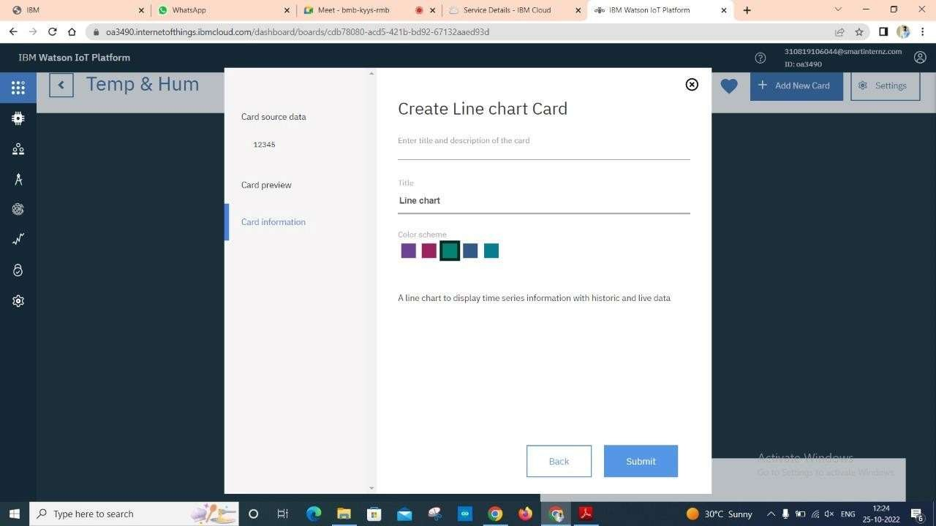

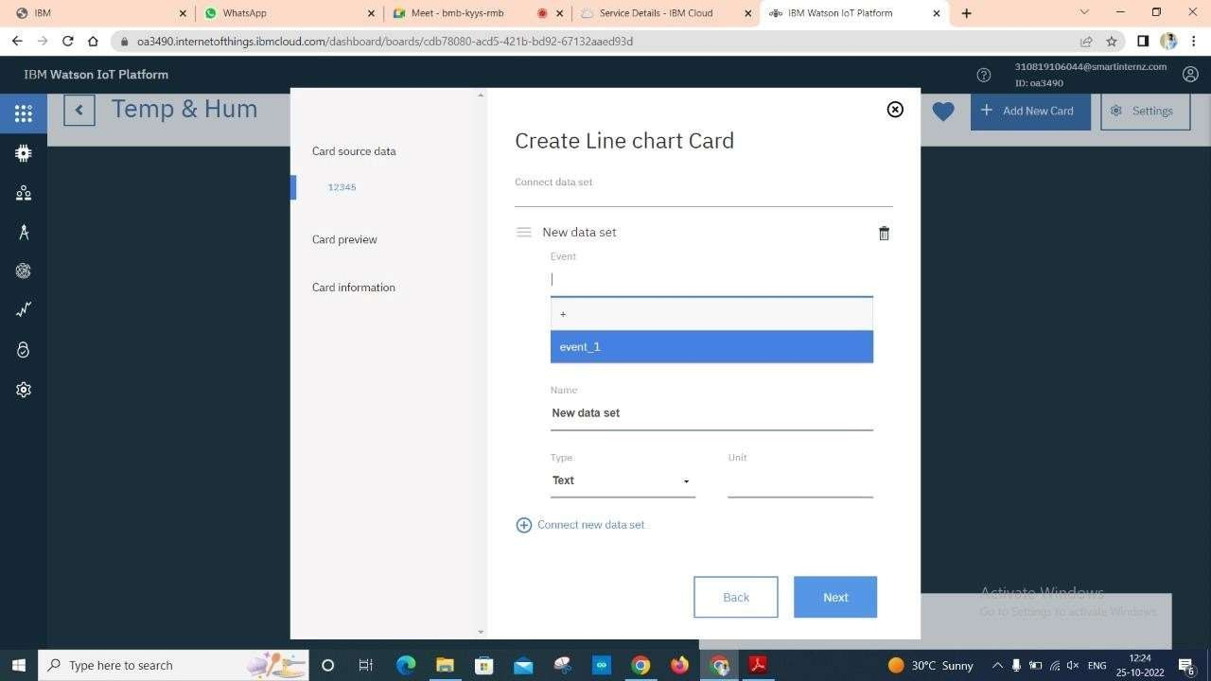

Step 39: Here is the Final graph.

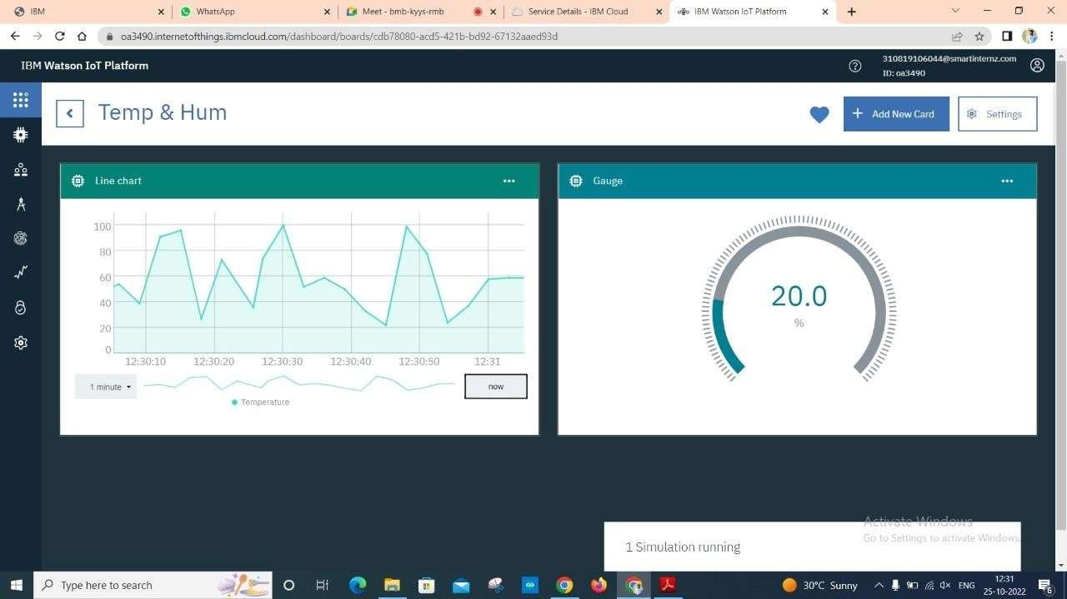

# Result:

An IBM Watson cloud for IoT and a device is created successfully.